**Source Code:**

create database faculty;

use faculty;

drop table if exists professor;

create table professor

(

ProfessorID int,

FullName varchar(50),

Contact bigint,

Address varchar(100),

Expertise varchar(40),

Income int

);

alter table professor add FacultyID int;

alter table professor drop column Income;

-- Inserting Value into Table

insert into professor values (101, 'Nisha', 984, 'Lalitpur', 'AI', 70000);

insert into professor values (102, 'Manish', 985, 'Chabahil', 'ML', 80000);

insert into professor values (103, 'Ramesh', 986, 'Kirtipur', 'DBMS', 90000);

truncate table professor;

delete from professor where FullName = 'Manish';

update professor set Address = 'Patan' where Address = 'Chabahil';

select * from professor;

**OUTPUT:**

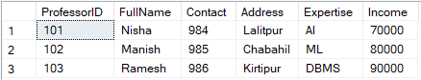

**Data insert into Teacher table**

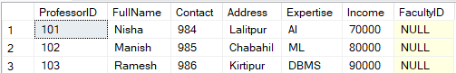

**Add column “FacultyID” into Teacher table**

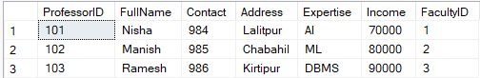

**Added values into “FacultyID”**

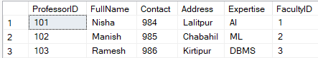

**Dropped “Income” from the table**



**Truncate record from table**

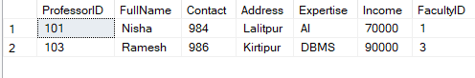

**Delete all record of student if name= ‘Manish’**

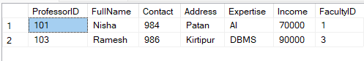

**Update to change the record address=‘Lalipur’ to ‘Patan’**